**FLPs who are getting relocated from one location to the other location, please use the below cost code**

|  |  |  |
| --- | --- | --- |
| **Project Number** | **Project Name** |  |
| 100022353 | IN12 Gen Mgmt GP-TDI | Hyderabad |
| 100022421 | IN14 Gen Mgmt GP-TDI | Chennai |
| 100022285 | IN10 Gen Mgmt GP-TDI |  |
| 100022319 | IN11 Gen Mgmt GP-TDI | Pune |
| 100022387 | IN13 Gen Mgmt GP-TDI | Chennai |
| 100022455 | IN17 Gen Mgmt GP-TDI |  |
| 100047492 | IN20 Gen Mgmt GP-TDI |  |
| 100049284 | IN21 Gen Mgmt GP-TDI |  |
| 100101835 | IN23 Gen Mgmt GP-TDI |  |
| 100104644 | IN24 Gen Mgmt GP-TDI |  |

**Book your Accommodation through I connect using the above project code based on your current location**

ICONNECT → Facilities → Travel Request →New Travel Request →Accommodation Request

**Go to your Iconnect Page – Click on to facilities**

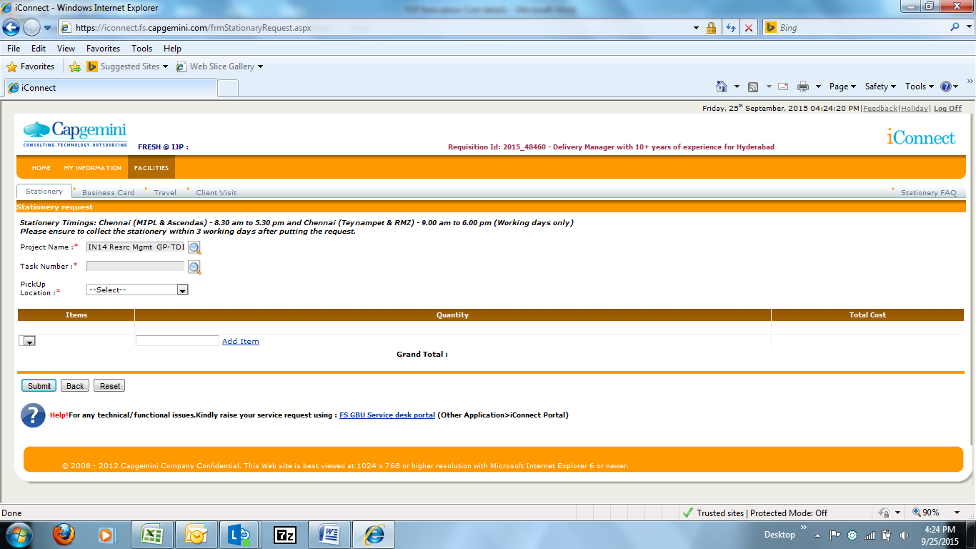

**Under Facilities – you can find the option called Travel – Click on travel**

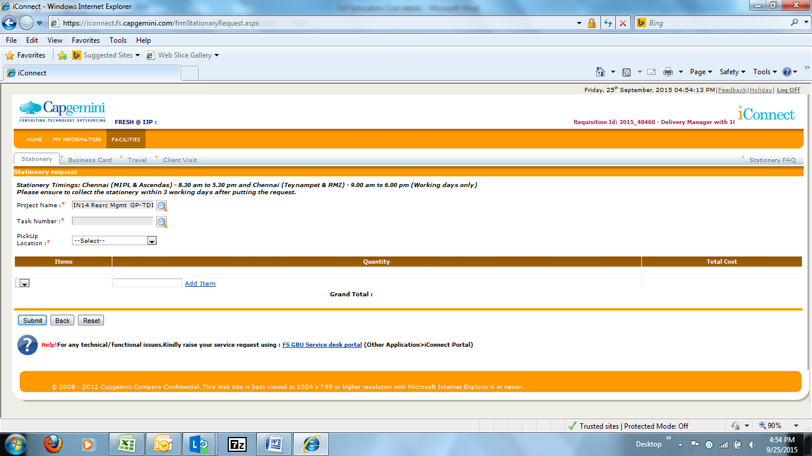

**Under this Travel page – on your right hand side you can see the Tab as New Travel Request – Click that**

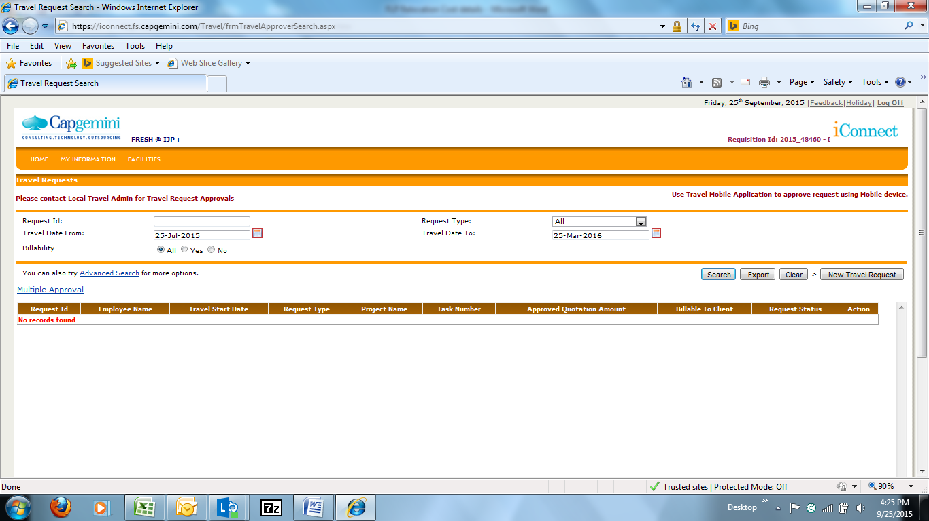

**After clicking the New travel request – you can find the below details**

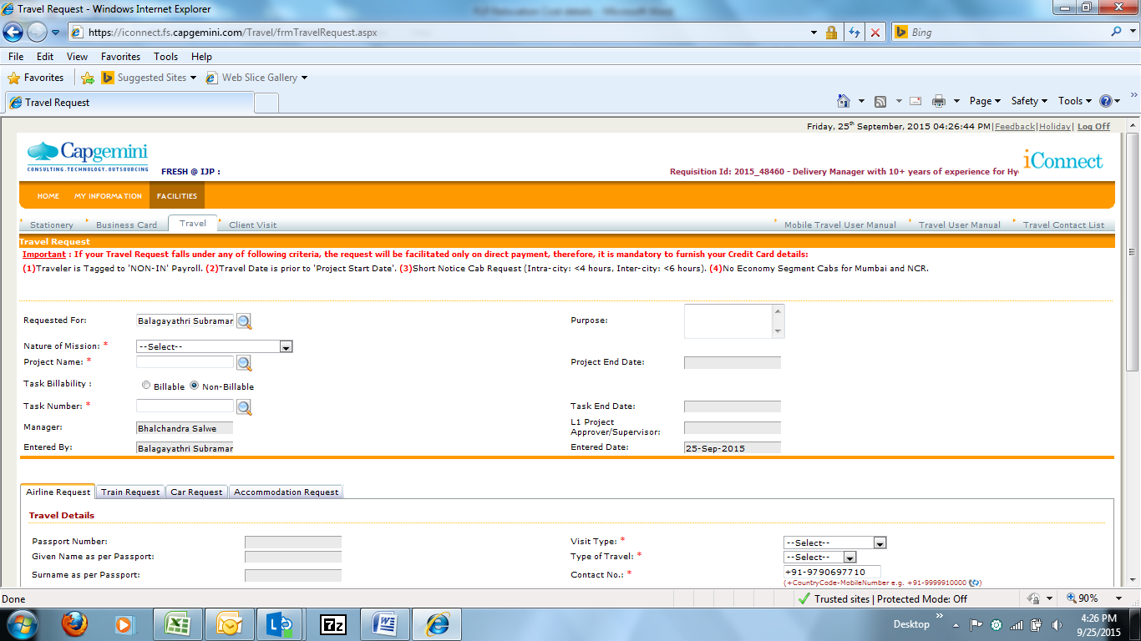

Once the above page is opened you can see 4 Tabs in the same page as Airline Request, Train Request, Car Request, and Accommodation Request

**To raise the Accommodation Request – Click Accommodation Request fill the necessary details**

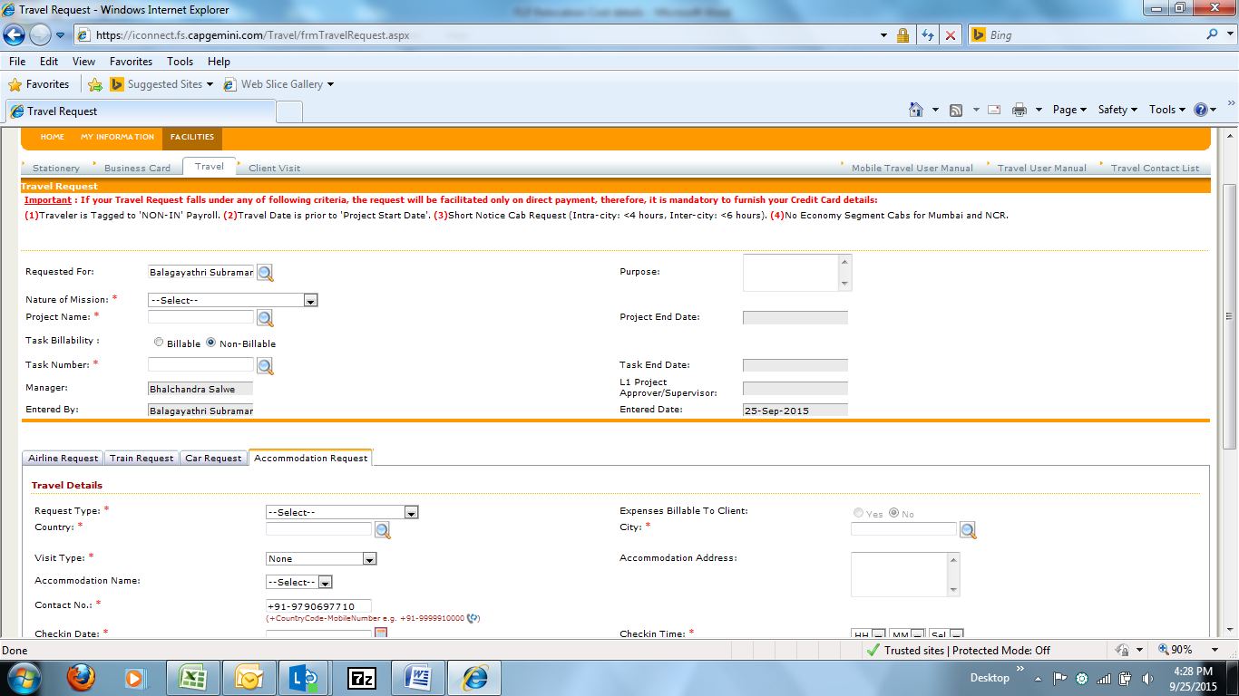

**After clicking the Accommodation Request you have give the necessary details**

**Nature of Mission:** Client or Vendor Activities

**Project Name:** (give the particular project name mentioned above as per your location)

**Task Number:** 0078

**Purpose:** Identified for a project in (Chennai / Hyderabad / Bangalore / Pune)

**Request Type:** You can select either Hotel- Domestic or Service Apartment – Domestic

**Country:** India

**City:** you can select the city in which you need the accommodation

**Visit Type:** Select Long Term / Short term

**Accommodation Name:** Select any from the available drop down list

**Check in date:** Give the correct check in date

**Check out date:** Give the correct check out date ( you are eligible for 7 days Accommodation)

**Room Type:** Select Single / Double

**Family Accompanying:** Select whether your family is accompanying as Yes / No

**Check In time:** Give the correct check in time

**Check out time:** Give the correct check out time

**Kitchen:** Yes / No (based on your need)

**Client Address:** Give the address which is mentioned in your TNF under New Assignment

**Requestor Remarks:** Just give as Relocating from ___________ location to __________ location towards the new project assignment

**After filling the necessary information submit your request**